Ventilation & Compression (Feedback & integration types) technical research

# Ventilation

Ventilation can be separated into two categories:

1. Making sure the patient has an open airway
2. Making sure the oxygen provided by the responder goes to the lungs.

To simulate the openness of the airway, the current baby patient simulator uses 2 IMU sensors, on the head and the torso of the doll, and examines the difference in trajectory, force and angle of the two sensors to check if the head of the baby is in the correct position compared to the body.

An IMU sensor is basically 3 different sensors in one, an accelerometer, a magnetometer and a gyroscope. All 3 sensors are 3 dimensional.

Furthermore, the current baby simulator also has an airway and lung simulation, by using tubes, pumps and an airflow sensor to measure the volume of the air going into the lungs of the baby.

Figure 1: Current implementation of the IMU sensors

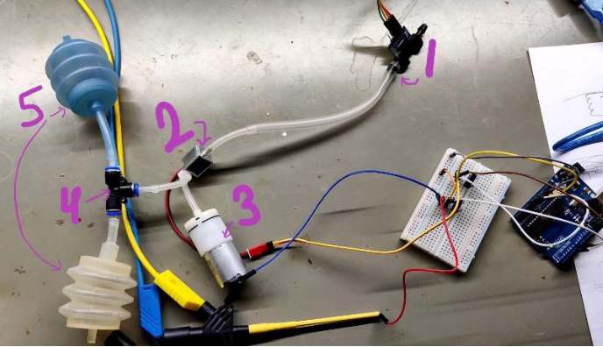

Figure 2: The airway and lung simulation test made by the S3 project group

A practical model from Waseda University in Japan was made using a conventional mannequin that is composed by seven parts: head, neck, chest, incisor teeth, tongue, vocal cord, and trachea. Sensor systems were embedded into the mannequin: improved Force Detection Sensor System (FDSS), Displacement Detection Sensor System (DDSS), Position Detection Sensor System (PDSS), Potentiometer. (http://www.takanishi.mech.waseda.ac.jp/top/research/cluster/WKA-1.htm#back_ground)

Figure 3: The WKA-1 sensor systems

# Compression

For the compression, we need to make sure that the responder makes a deep enough compression, that he makes enough compressions per minute, and that the force is applied at the appropriate position in the chest.

The current baby simulator uses a Time of Flight(ToF) sensor to measure the depth of the compression, and with software it also counts the compressions made within a time period. A ToF sensor emits a light and measures the round trip time of its reflection.

Figure 3: The test setup used by the S3 project group for the compression

A research paper was also made where the proposed method uses accelerometer sensors, one placed on the patient's chest, the other beside the patient. The acceleration-to-position conversion is performed using discrete-time digital signal processing (DSP). Instability problems due to integration are combated using a set of boundary conditions. The proposed algorithm is tested on a mannequin in harsh environments, where the patient is exposed to external forces as in a boat or car, as well as improper sensor/patient alignment. The overall performance is an estimation depth error of 4.3 mm in these environments, which is reduced to 1.6 mm in a regular, flat-floor controlled environment. ( <https://ieeexplore.ieee.org/abstract/document/983461>)

# Feedback

There are many types of feedback implemented into mannequins. The most common types of feedback are visual:

1. The chest rising when oxygen is flowing to the patient’s lungs
2. LED’s that show if enough chest compressions are made in a minute
3. LED’s on the cheek of the patient to signal respiratory distress
4. Tablet/computer/mobile phone showing different metrics on a screen

There is also audio feedback, i.e. a speaker mimicking noises the baby would make, RFID tags in specific places of the body etc.

Last, there Is haptic feedback, which can be simulated by motors that provide movements and vibrations, 3-d printed bones that will resist the force from chest compressions, fluid systems that mimic blood circulation.